Tupperware Survey

Name : _______________________________________Date : _________________Email : ________________________________
Telephone (Home) : _____________________________________ Telephone (other): ___________________________________
Address : ________________________________________ Town :__________________ Postal Code:________________________
Consultant :__________________________________________ Team : _______________________________________________

1. What do you think we are going to talk about today? ______________________________________________________
2. In order to better understand your needs :
a) Do you work outside of home ? Yes  No 
Doing what ? ________________________________
How long have you been doing this ?___________________
b) Do you have a partner ? Yes  No 
c) Do you have children ? Yes  No 
Age : ________ Age : ________ Age : ________
d) What do you do in your spare time for yourself ?
_________________________________________________
3. How long have you known about Tupperware ?
___________________________________________________
4. What is your favourite product ?
___________________________________________________

5. When did you go to your last Tupperware party? __________
Have you ever been a Hostess ? If Yes, when ?______________
What presents did you choose? _______________________
If no, why not ? ____________________________________

6. Do you know or possess (when the reponse is «Yes», ask the client what she would say to sell it to you):
a) FridgeSmart Medium ? Yes  No 
b) Freezer Mate Medium 1 ? Yes  No 
c) Tupperwave Stack Cooker? Yes  No 
d) Vent'n'Serve Medium Deep? Yes  No 
e) Modular Mate ? Yes  No 
f) Quick Chef Pro ? Yes  No 
7. To better understand how you use your Tupperware products, would you allow me to look with you at your:
Refrigerator __________ (number)
Freezer __________ (number)
Pantry __________ (number)
Cupboards __________ (number)

8. Did you know that we now offer parties with cooking rather than the presentations that we used to do? Yes  No 
Give an example of salsa in the Quick Chef, potatoes in the Vent'n'serve and chicken in the Tupperwave.
9. With the help of the Kit Game, give the value of the Quick Chef and the Breakfast Maker which is about $110.
Ask the Client: What would you say if I added onto that the FridgeSmarts & the FreezerMates for the same price? And everything else you see in the picture? It’s your first privilege as a host. All that for $110!!!

10. If you choose to do a Tupperware Party at your house, you will get showered with gifts. Do you know the exclusive privileges that exist JUST for Hostesses?
Purchase of the kit for $ 110 Yes  No 
Free Tupperware once you reach $300
In sales (up to 20% in credits) Yes  No 

Sets at 50% off once you reach $300
in sales (up to 3 sets) Yes  No 

11. If you were a Tupperware host, what systems would you choose for your gifts....
a) The FridgeSmarts for fruits and vegetables
b) The Vent'n'Serves for microwaves
c) The FreezerMates for freezing
d) The Modular Mates for the pantry

12. If you decided to host a Tupperware Party, what would be the best time of the week to do the party?​
Beginning of the week  End of the week  Week-end 
Morning  Afternoon  Evening 
Date : _____________________ Hour : ____________
Carry out the Hostess planning now if your client has decided to do a Tupperware Party.

- I would like to give you an invitation to one of our Information Sessions. You will learn about the company, the products, and the business opportunity.
Yes  No 

- Explain that we are on a recruitment drive and do your Tupperstory.

15. Do you have anyone that you could refer me to?
For a Party : ___________________________________
For the 13 week trial : ___________________________

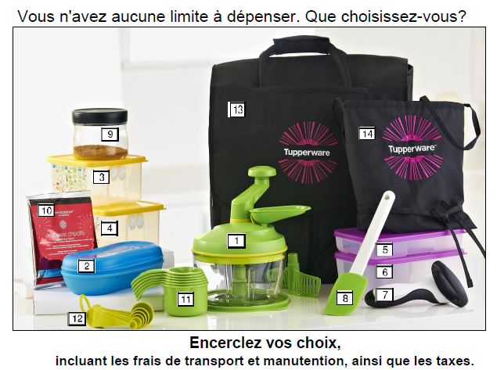
You have an unlimited budget. What would you choose?

Circle your choices
Include shipping & taxes
1 – Quick Chef Pro | $ 83.00 |  |  | 8 – Silicone Spatula | $ 23.00
2 – Microwave Breakfast Maker | 24.00 |  |  | 9 – CounterScapes Small | 14.00
3 – FridgeSmart Small | 18.00 |  |  | 10 – Chipotle Spices | 11.00
4 – FridgeSmart Medium | 23.00 |  |  | 11 – Measuring Cups | 21.00
5 – FreezerMate Medium 1 | 11.00 |  |  | 12 – Measuring Spoons | 18.00
6 - Freezer Mate Medium 2 | 12.50 |  |  | 13 – Transport bag | 30.00
7 – Can Opener | 42.00 |  |  | 14 – Apron | 30.00
 |  |  |  | Total products 1 to 14 :  _____________________________ | $ 360.50  ______________
 |  |  |  | Shipping and Delivery : _____________________________ | 3.95 ______________
 |  |  |  | Sub Total:  _____________________________ | 364.45  ______________
 |  |  |  | Taxes (13%)  _____________________________ | 47.37 _____
 |  |  |  | Grand total : | $ 411.82
Material Necessary for Survey:
- Gift for filling in the survey
- Agenda with dates highlighted

Please telephone the office: 519-883-1352

- My name is :
- I just did a survey with :
- I will do a Party on :

- Survey
- One product from each system (Fridgesmart, Vent'n'Serve,
Freezer Mate, Modular Mate, Quick Chef and TupperWave,
plus the Breakfast Maker)
- Planning envelope :
- Brown Envelopes
- Dating Gift
- Kit Game

